CALL FOR SUBMISSIONS:
Community engagement for inclusive rural transformation and gender equality
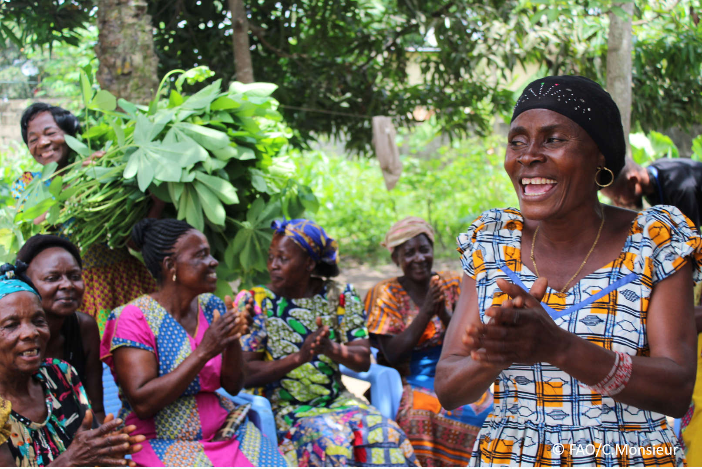
The objective of this call for submissions is to collect good practices, experiences, and lessons learnt on the use of community engagement for inclusive rural transformation and gender equality. The initiative, organized by the Rural Transformation and Gender Equality Division (ESP), seeks to gather insights from a diverse range of contributors, both within FAO and from external stakeholders. Its goal is to share knowledge, foster learning, and guide the scaling up of community engagement and community-led collective action to leave no one behind. The call builds on FAO's past efforts in this area, such as the Community Engagement Days series of webinars.
The call for submissions is open until 27 November 2024.

How to take part in this call for submissions:
To take part in this Call for submissions, please register to the FSN Forum, if you are not yet a member, or “sign in” to your account. Please review the topic note to understand the criteria we are considering for this call. If you wish to learn more about community engagement, you may refer to the background document. Once you have completed this submission template, upload it in the box “Post your contribution” on the call webpage, or, alternatively, send it to fsn-moderator@fao.org.
Please keep the length of submissions limited to 1,500 words and feel also free to attach relevant supporting materials.

Template for submissions

Contact person | Name: Thais Bessa  Organization/Unit: Tetra Tech  Country: USA  Email address: thais.bessa@tetratech.com
Name/title of the good practice | Promoting women’s empowerment and secure land rights in Malawi.
Where is the good practice taking place? (Multiple selection allowed) | ☐ Europe and Central Asia  ☐ Latin America and the Caribbean  ☐ North Africa and Near East  ☒ Sub-Saharan Africa  ☐ Asia and the Pacific  ☐ North America  ☐ Global
Affiliation | ☐ Farmer and producer organizations  ☐ Trade Union  ☐ Informal community-based, farmer-based or self-help group  ☐ Research and academia  ☐ Government  ☐ Local/traditional authorities  ☒ Private Sector  ☐ Civil Society Organization  ☐ Intergovernmental Organization (e.g. UN system, World Bank)  ☐ Resource Partner/Donor  ☐ Other (please specify)
In which sector(s) and context (s) have you used this community engagement good practice? (Multiple selections allowed) | ☐ Education  ☐ Health and Sanitation  ☐ Food production in agrifood systems (please also tick the sub-categories)  ☐ Crop cultivation  ☐ Fisheries and aquaculture production  ☐ Livestock  ☐ Forestry  ☐ Agroforestry  ☐ Horticulture  ☐ Apiculture (beekeeping)  ☐ Agroecology and sustainable farming practices  ☐ Soil and water management  ☐ Other: ____________  ☐ Post-production in agrifood systems (please also tick the sub-categories)  ☐ Processing and value addition  ☐ Marketing and retailing  ☐ Transporting  ☐ Food loss and waste  ☐ Packaging  ☐ Storage  ☐ Distribution  ☐ Other _________  ☒ Gender Equality  ☐ Climate Action  ☐ Citizenship and Governance  ☐ Social Protection  ☐ Humanitarian and protracted crisis  ☐ Conflict resolution, peace and resilience  ☐ Digital innovation  ☒ Other sector (please specify) _Land and Resource Governance ________
Who are the financial partners supporting this good practice, if applicable? | USAID, Government of Malawi
- In a few sentences, summarize your community engagement good practice.
To promote women’s economic empowerment (WEE) through systematic land documentation in Malawi, the project integrated a gender lens into each stage of the land documentation process, engaged traditional leaders as champions, facilitated dialogues on family roles and responsibilities at the household level, and supported community-led diffusion approaches to build broad-based support for women’s land rights.
- What problem(s) or challenge(s) does your good practice aim to address through community engagement?
As land is a critical asset for rural men and women, securing land tenure and property rights through documentation can reduce conflict and vulnerability to property grabbing, while creating incentives for households to make long-term investments in their land and improve their livelihoods. Yet systematic land documentation efforts rarely include robust approaches to address underlying problems of disenfranchisement and social exclusion. By taking a concerted inclusive, WEE-based approach to land documentation, this project aimed to address barriers to women’s economic empowerment at the household and community levels to strengthen ownership and control over land for women, youth, and other marginalized groups as a pathway for social and economic empowerment.
- Describe your good practice in more detail. Include the main guiding principles, the desired changes or outcomes you aim to achieve (Theory of Change), and the key phases of implementation.
The USAID Integrated Land and Resource Governance (ILRG) project implemented an inclusive systematic customary land documentation process in Mwansambo, Malawi to ensure that women, youth, the elderly, people with disabilities, and other marginalized groups were able to participate in and benefit from land registration. The project adopted a holistic approach, with interventions focused on capacity strengthening and locally-led community engagement. Key stakeholders, including government officers, land adjudication enumerators, and local land governance committees and courts, received training on promoting women’s economic empowerment and mitigating gender-based violence within the land documentation process. Women elected to local land governance committees overseeing land documentation received training on technical and socioemotional skills such as confidence, assertiveness, negotiation, and conflict management, allowing them to meaningfully carry out their roles. Traditional leaders participated in a series of dialogues to identify barriers that hindered women’s land rights and devised actions to lead change at the community level. Household-level dialogues on family roles and responsibilities provided men and women space to discuss inequalities influencing the division of labor, control of land and other resources, decision-making, and gender-based violence. Together they devised individual and joint actions to change beliefs, attitudes, and behaviors to promote women’s economic empowerment and improve household income earning potential. From this group, the project identified highly engaged individuals to act as community champions to lead organized diffusion efforts, facilitating discussions about the benefits of inclusive and joint land ownership and decision-making through door-to-door visits and community gatherings. These efforts were complemented with communications materials (such as comic booklets), radio programs, and community soccer games where messages about the value of women’s land rights were shared broadly.
- Who are the key actors and stakeholders involved in the design and implementation of the good practice, and what are their respective roles? Consider local partners, government, local authorities, community radios, civil society, research, the private sector, etc.
The project was implemented by the USAID Integrated Land and Resource Governance (ILRG) project in partnership with the Malawi government. At the community level, the key actors and stakeholders were:
- Traditional leaders: As holders of local culture who are responsible for the allocation of customary land, they have great influence over community members and the land registration process. The project engaged them as key champions and role models for advancing women’s land rights.
- Local land governance committees and courts: As part of the customary land documentation process, communities elected six members (gender balanced as required by law) to customary land committees. The project provided technical support to committee members and targeted training to support women’s meaningful participation. The project also provided training on women’s economic empowerment and gender-based violence to local land courts responsible for dispute resolution.
- Community members: Communities were sensitized about land rights and the benefits of equitable and inclusive land documentation throughout the project. Men and women in the same household were brought together to discuss and devise strategies to change inequality. Community champions led organized diffusion efforts to ensure local ownership and sustainability.
- How does your intervention ensure inclusivity and equal and meaningful participation within the community?
Describe how your intervention includes and engages different groups within the community. Consider aspects like gender, age, ethnicity, disability status, livelihoods, and other specific conditions (e.g., people living in prolonged crisis, migrants, refugees). Explain how your intervention engages diverse segments of the rural community. Highlight the specific actions or strategies you use to reach these groups. If applicable, mention if your intervention uses specific approaches such as gender-responsive, gender-transformative, intersectionality, or other methods to ensure inclusivity and gender equality.
The project sought to address underlying barriers and inequalities that restrict women’s ability to access and own land alongside systematic land documentation. The approach integrated a women’s economic empowerment lens into each step of the land documentation process and worked with men and women in rural households and traditional leaders to promote community-led sensitization and behavior change. Efforts were made to ensure times, locations, and formats for meetings and training were accessible for women, youth, the elderly, and people with disabilities. Dialogues were led by local consultants and used participatory and adult learning principles to ensure they were accessible to people with a variety of literacy levels. Training on technical and socioemotional skills for women elected to customary land committees was also facilitated by local experts and used practical exercises and role-playing. During the dialogues on family roles and responsibilities, traditional leaders devised actions they wanted to take to lead change in their communities. They chose to focus on developing by-laws on equitable land rights and facilitating their own series of community awareness-raising meetings. Some traditional leaders with limited literacy skills engaged local youth to help them document outcomes from the meetings. Community champions used communications materials such as posters and comic booklets as conversation-starters when they sensitized other community members. These materials were also distributed in strategic locations, including the village center, water collection points, schools, churches, and markets. Radio programming featured jingles created by local artists and had government officers and traditional leaders responding to questions submitted by listeners. The radio programs were broadcast throughout the whole province, reaching people beyond the target area of Mwansambo who will participate in systematic land registration in the future.
- By using community engagement, what results and impacts have your good practice achieved?
Please provide specific examples and evidence demonstrating the effectiveness of your intervention, focusing on both qualitative and quantitative outcomes related to livelihoods and well-being improvements.
The project was able to register over 9,000 land parcels in Mwansambo, Malawi, securing customary land rights for 42,000 people. The inclusive approach resulted in women being named on 68% of land certificates, compared to 38% under a previous pilot in the same area that did not integrate an inclusive approach into land documentation. Qualitative data revealed increased feelings of tenure security among those who had their land rights documented, with some reporting that they had planted additional trees and crops on their land now that they were sure they would be able to access their plots in future seasons without fear of land grabbing.
- Among these results, has the good practice led to improvements in terms of gender equality, women’s empowerment, and/or social inclusion?
Describe the behavioral changes in terms of gender that the good practice promotes, emphasizing agency, leadership, and participation in local governance. Include efforts to challenge discriminatory norms and unequal power dynamics. Highlight also how the intervention has supported the well-being (including psychological resilience) of marginalized groups and enhanced their inclusion and participation in decision-making processes.

Measuring shifts in attitudes and behaviors related to women’s economic empowerment is a challenge in and of itself. The activity used a baseline and endline survey to compare agreement with statements about women’s land rights. The data showed encouraging shifts in a very short period (less than two years). This was further supported by qualitative data gathered by local consultants, who reported that both men and women said that husbands are beginning to share in household work and women are increasingly involved in decisions about land and household income. Likewise, agreement with statements asking whether gender-based violence is justified declined. Government officers, traditional leaders, customary land committee members, and community members expressed improved awareness of barriers to women’s economic empowerment and a more favorable attitude towards women, orphans, people with disabilities, and other vulnerable groups being included in land registration. There were also shifts in acceptance that women and men who move into a village should be entitled to land despite their marriage setup, which defies very ingrained social norms about land rights based on marriage and village of origin. Traditional leaders took concrete steps to act as champions, modeling positive behavior change like registering their own land with their spouses and independently sensitizing over 12,000 people on women’s land rights.
- What key challenges did you encounter while implementing the community engagement activities, and how did you address them?
Include any resistance from communities, pushback, or issues related to unequal power dynamics, if applicable.
The main challenges included initial resistance to integrating a women’s economic empowerment approach into customary land registration work, with key stakeholders believing that the equality provided by the legal framework was sufficient and that a focus on women’s land rights might be divisive. Continued advocacy, emphasis that social inclusion goes beyond promoting women’s rights, and constant feedback on inclusion-related impacts and learnings helped diminish but not fully overcome this resistance. Another challenge was the need for further preparatory work, especially in resolving community boundary disputes that prevented some land from being documented. Coordination between local and district stakeholders was also weak, especially at the beginning, and affected dispute resolution and gender-based violence mitigation and response. Finally, most women’s land rights sensitization activities happened in parallel with documentation, with many participants feeling that the information came in too late. This suggests that sensitization should precede land documentation activities to provide time for dialogues about women’s land rights and the benefits of women’s economic empowerment to take root and create an enabling environment for households to make informed decisions about inclusive land documentation.
- What are the key lesson learned from your community engagement good practice?
- Allow sufficient time for planning and preparation to select intervention areas, align expectations, and resolve broader land boundary issues.
- Carry out a robust analysis to inform women’s economic empowerment (WEE)-specific activities and WEE integration in the whole land registration process.
- Invest in gender-balanced teams of enumerators/data collectors, and provide them with WEE training. Since they are responsible for land adjudication and parcel boundary mapping, enumerators are at the frontline for WEE integration.
- Implement WEE capacity strengthening for all stakeholders involved in the land registration process to increase understanding and buy-in.
- Ensure WEE content is part of initial community outreach on land rights, with continued sensitization throughout the documentation process.
- Gender quotas can be important for local land committees, but women need additional support to meaningfully participate in land governance.
- Invest in traditional leaders as key agents of change to promote WEE in customary land registration and governance.
- Focus on shifting restrictive family roles and responsibilities at the household and community levels.
- Build support and resources for land dispute resolutions that respect women’s land rights and are sensitive to gender-based violence risks.
- Create space for long-term change; though WEE integration generates positive results, there is persistent resistance to registering land in the name of women in patrilocal marriage systems (where women move to their husband's village/ land upon marriage).
- Has this practice been replicated in the same context or in different contexts?
What are the required conditions to replicate and adapt the practice in another context/geographical area?
The project has supported a similar WEE dialogue approach with traditional leaders in Zambia to promote shifts in attitudes towards women’s land rights. The project also engaged men and women in farming households in dialogues about family roles and responsibilities in India and Ghana to promote women’s participation and visibility within agricultural supply chains. Adapting the facilitation tools to the local context is key, as is engaging a local facilitator to lead the dialogues, as they understand the local context and are relatable and accessible at the community level. The project team is currently adapting the household dialogue tools developed for the cocoa value chain in Ghana for Cote d’Ivoire, incorporating how cocoa sourcing and women’s roles differ between the two contexts.
- How sustainable are the results achieved by this good practice?
Describe the key elements that need to be in place to make the initiative sustainable, including enabling environment (legal and policy frameworks and institutions), local ownership, accountability, etc.
Based on this project, the Government of Malawi plans to scale the customary land documentation approach to other areas in the country. The project left behind guides, tools, and reference materials to support WEE integration into this approach to ensure lessons are built on and scaled.
- Based on the conversations FAO held during the Community Engagement days, a definition of community engagement for empowerment was proposed:

“Community engagement for empowerment and community-led collective action can be defined as an inclusive and participatory process that enables community members to become active agents of change in decisions affecting their lives, health, and environment. This process develops their capacity to achieve sustainable outcomes for improved rural livelihoods. Embracing a rights-based approach, it prioritizes the agency and participation of all community members, regardless of gender identity, sexual orientation, age, ethnicity, caste, socioeconomic status, political affiliation, migration status, or ability/disability. Indeed, inclusive approaches recognize the complexities of overlapping marginalization and discrimination that can exclude different community members from decision-making processes and implement strategies to foster their participation, agency and empowerment.”

We invite you to contribute to this definition. What would you add or change? Please share your thoughts, suggestions, and any additional elements you believe are crucial for a comprehensive understanding of community engagement approaches aimed at community-led collective action for inclusive rural transformation, people’s empowerment and gender equality.

In addition to a rights-based approach, it is also important to take an assets-based approach that recognizes the expertise within communities, and the value of a diversity of perspectives to improve the inclusivity, quality, and durability of community decision-making.

- Based on your experience, what gaps or areas for improvement still need to be addressed in the field of community engagement?
To reinforce inclusive community engagement, it is important to share information back to communities about the impact of inclusive efforts so they can understand what changed and make informed decisions about whether the efforts are worth continuing beyond the life of individual projects or activities.
- What do you think is FAO's role in the field of community engagement? How can FAO support and enhance interventions like yours, if applicable? Consider aspects such as policy advocacy, capacity development, funding, technical assistance, knowledge production and sharing, and fostering partnerships.

FAO could play a role in knowledge production and sharing, particularly contributing to the evidence base on impacts of inclusive community engagement – how does it improve results for a range of development objectives? What are the essential elements of inclusive community engagement? What can we learn from failed projects or activities?
Link(s) to specific references about your good practice (e.g. reports, communication products, videos, articles) | Please include attachment(s) or add here link(s) to documents/videos/podcasts/other with specific references.  https://www.land-links.org/document/lessons-learned-integrating-gender-equality-and-social-inclusion-into-customary-land-documentation-in-malawi/  https://www.land-links.org/document/gender-norms-dialogue-for-traditional-leaders-in-malawi-training-manual/  https://www.land-links.org/document/training-manual-for-household-dialogues-on-gender-norms-in-the-context-of-land-rights-in-malawi/  https://www.land-links.org/document/practical-implementation-guide-on-gender-equality-and-social-inclusion-in-customary-land-registration-in-malawi/

The call for submissions is directly aligned with the thematic components of collective action within FAO's Programme Priority Areas (PPAs), specifically Better Life 1 (Gender Equality and Rural Women’s Empowerment), Better Life 2 (Inclusive Rural Transformation) and Better Life 3 (Agriculture and Food Emergencies).

